1. **To check if the given no is even or odd**

**Program:**

#To check if the given no is even or odd

repeat = True

while repeat:

num = int(input("Enter a number: "))

if num%2 == 0:

print("It is Even Number.")

else:

print("It is Odd Number.")

repeat = input("Do you want to repeat ('Y','N'): ")

if repeat in ['y', 'Y', 'yes', 'Yes', 'YES']:

continue

else:

repeat = False

**Output:**

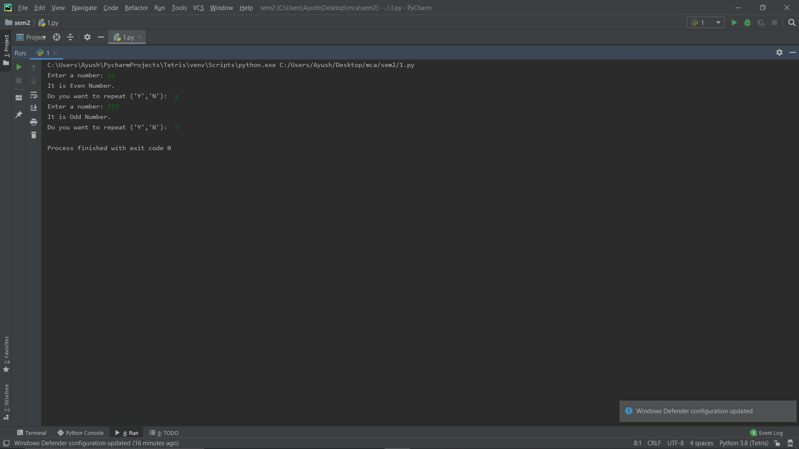

1. **Write a Program to Take in the Marks of 5 Subjects and Display the Grade**

**Program:**

# Write a Program to Take in the Marks of 5 Subjects and Display the Grade

repeat = True

while repeat:

subjects = ["English", "Science", "Maths", "History", "Geography"]

total = 0

result = "Passed"

for i in subjects:

print("Enter marks for ", i, "(out of 100):")

mark = int(input())

if mark < 40:

result = "Failed"

total += mark

print("\nThe student ", result, " total marks scored by student is ", total, " and the percentage scored by student is ", (total / 500) * 100)

repeat = input("\nDo you want to repeat ('Y','N'): ")

if repeat in ['y', 'Y', 'yes', 'Yes', 'YES']:

continue

else:

repeat = False

**Output:**

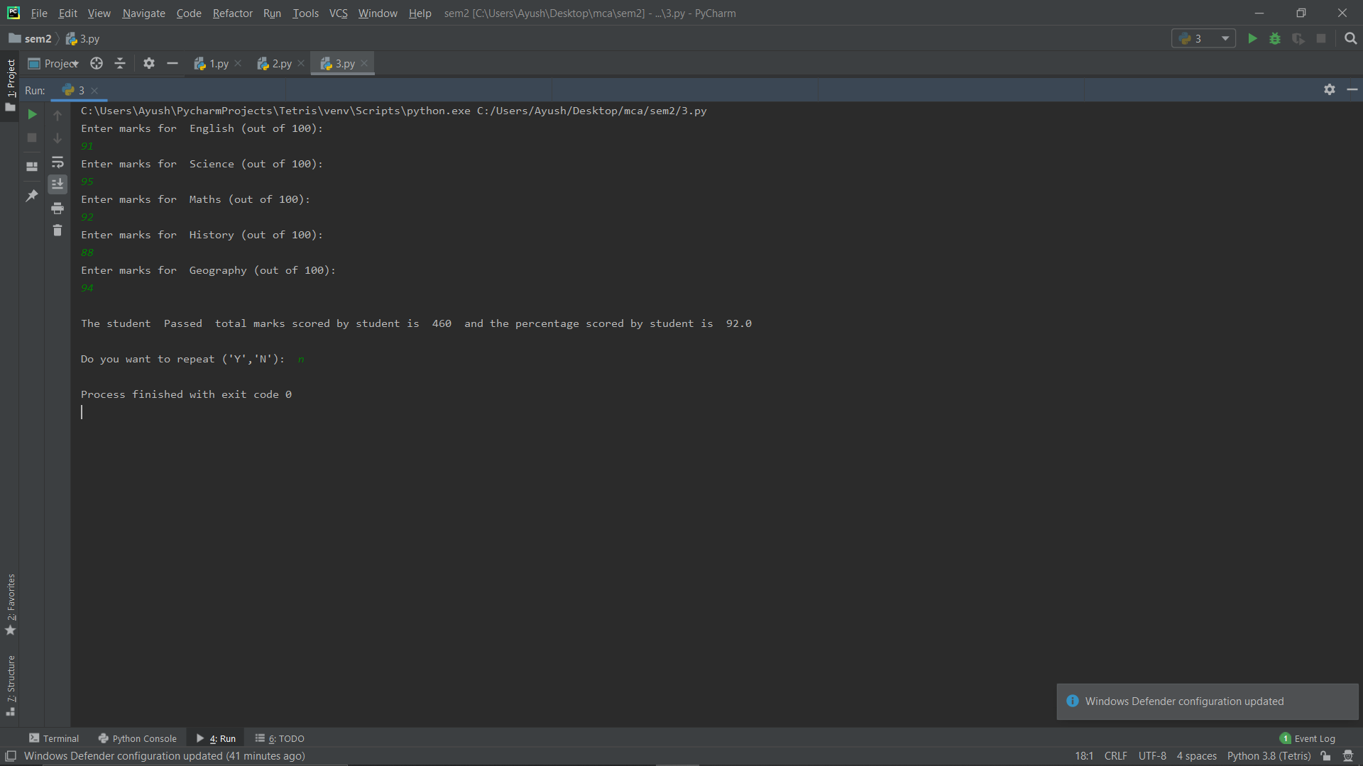

**3. Display prime number between 1 and 100**

**Program:**

# Display prime number between 1 and 100

import math

i = 1

print("Prime Numbers are: ")

while i <= 100:

flag = True

for j in range(2, int(math.sqrt(i)) + 1):

if i % j == 0:

flag = False

if i > 1:

if flag:

print(i, " ")

i += 1

**Output:**

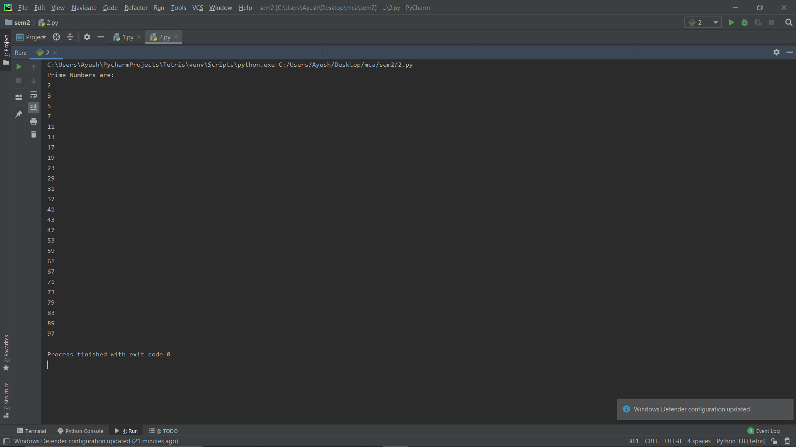

**4. To check if the number is Armstrong or not**

**Program:**

# To check if the number is Armstrong or not

repeat = True

while repeat:

num = int(input("Enter a number: "))

power = 0

temp = num

while temp > 0:

power += 1

temp = int(temp / 10)

sum = 0

temp = num

while temp > 0:

sum += int((temp % 10) ** power)

temp = int(temp / 10)

if sum == num:

print("Number entered is an Armstrong number.")

else:

print("Number entered is not an Armstrong number.")

repeat = input("\nDo you want to repeat ('Y','N'): ")

if repeat in ['y', 'Y', 'yes', 'Yes', 'YES']:

continue

else:

repeat = False

`**Output:**

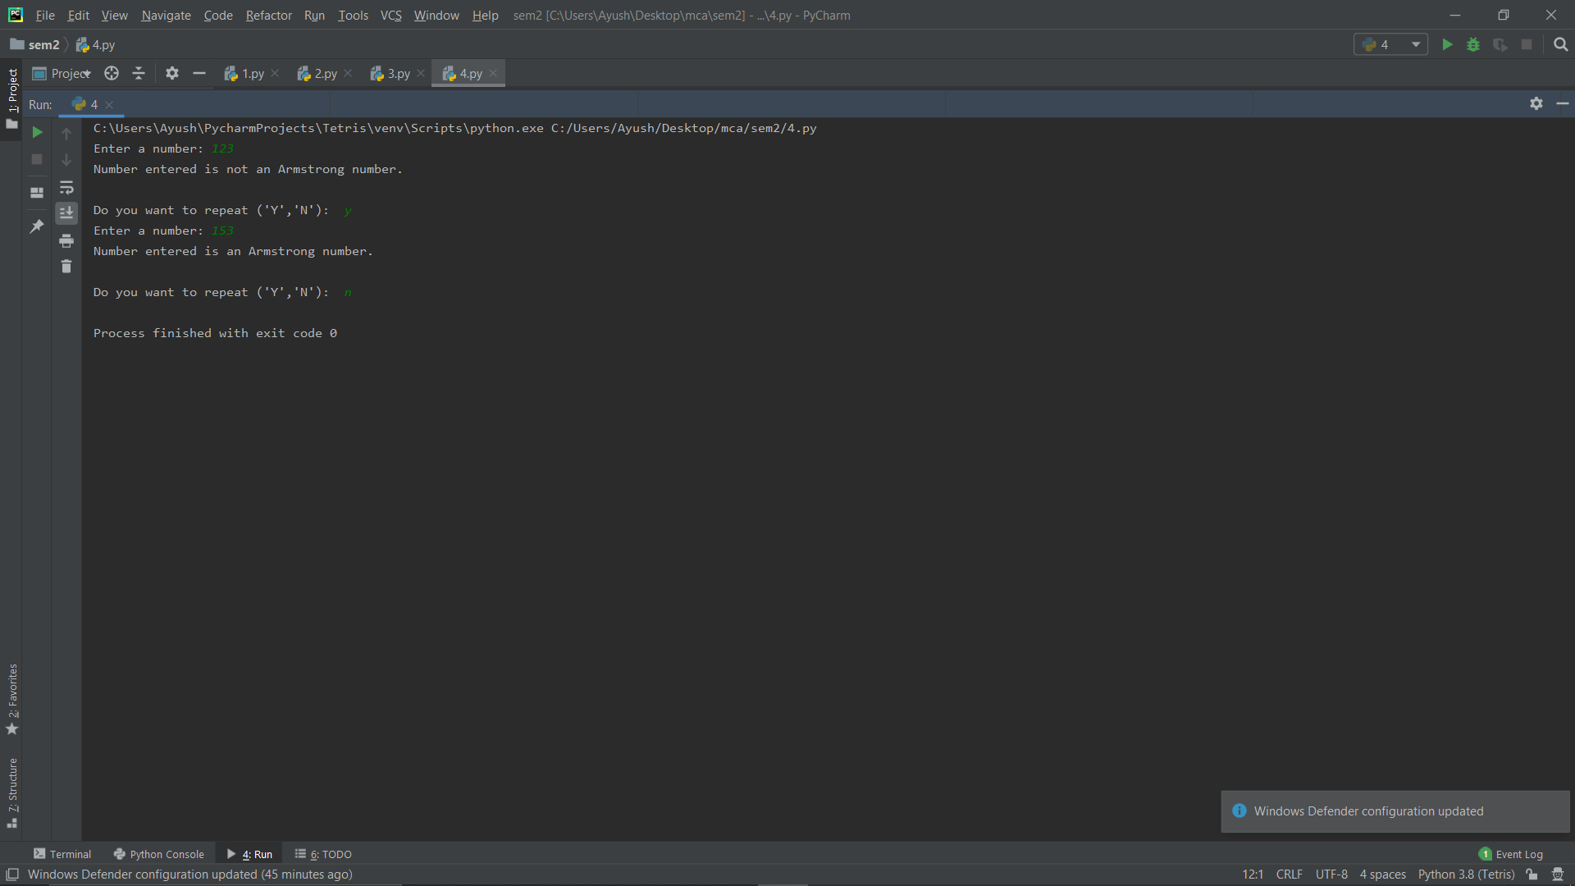

**5. To check whether the character entered is vowel or consonant**

**Program:**

# To check whether the character entered is vowel or consonant

repeat = True

while repeat:

ch = input("Enter an Alphabet: ")

vowels = ['A', 'E', 'I', 'O', 'U', 'a', 'e', 'i', 'o', 'u']

found = False

for i in vowels:

if i == ch:

found = True

if found:

print("The alphabet you entered is a vowel.")

else:

print("The alphabet you entered is a consonant.")

repeat = input("\nDo you want to repeat ('Y','N'): ")

if repeat in ['y', 'Y', 'yes', 'Yes', 'YES']:

continue

else:

repeat = False

**Output:**

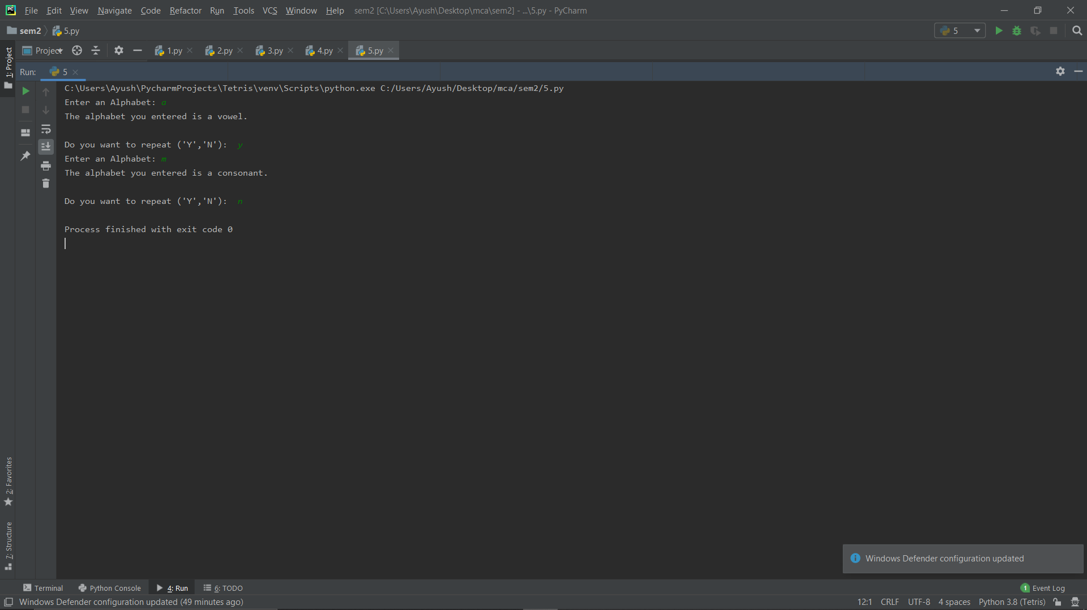

**6. To add two matrices**

**Program:**

matrix1 = []

matrix2 = []

for a in range(2):

print("Enter elements in Array ", a+1, ": ")

for i in range(3):

temp = []

for j in range(3):

temp.append(int(input()))

if a == 0:

matrix1.append(temp)

else:

matrix2.append(temp)

for i in range(3):

for j in range(3):

print(matrix1[i][j] + matrix2[i][j],end = " ")

print()

**Output:**

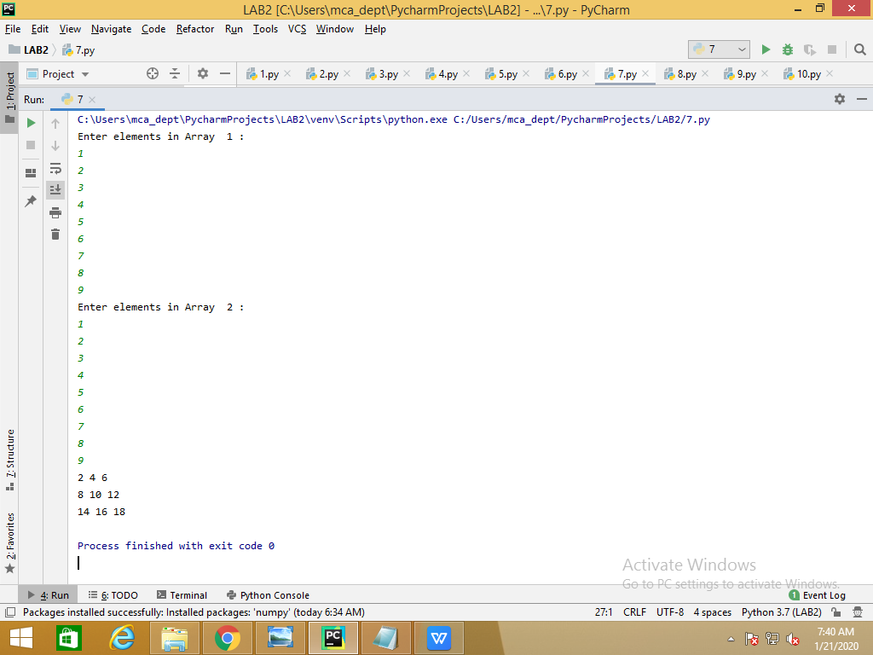

**7. To convert month name to a number of days**

**Program:**

repeat = True

month_days = [31, 28, 31, 30, 31, 30, 31, 31, 30, 31, 30, 31]

month_name = ["jan", "feb", "march", "apr", "may", "jun", "jul", "aug", "sep", "oct", "nov", "dec"]

while repeat:

month = input("Enter Month: ")

for i in range(12):

if month == month_name[i]:

print(month_days[i])

repeat = input("Do you want to repeat ('Y','N'): ")

if repeat in ['y', 'Y', 'yes', 'Yes', 'YES']:

continue

else:

repeat = False

**Output:**

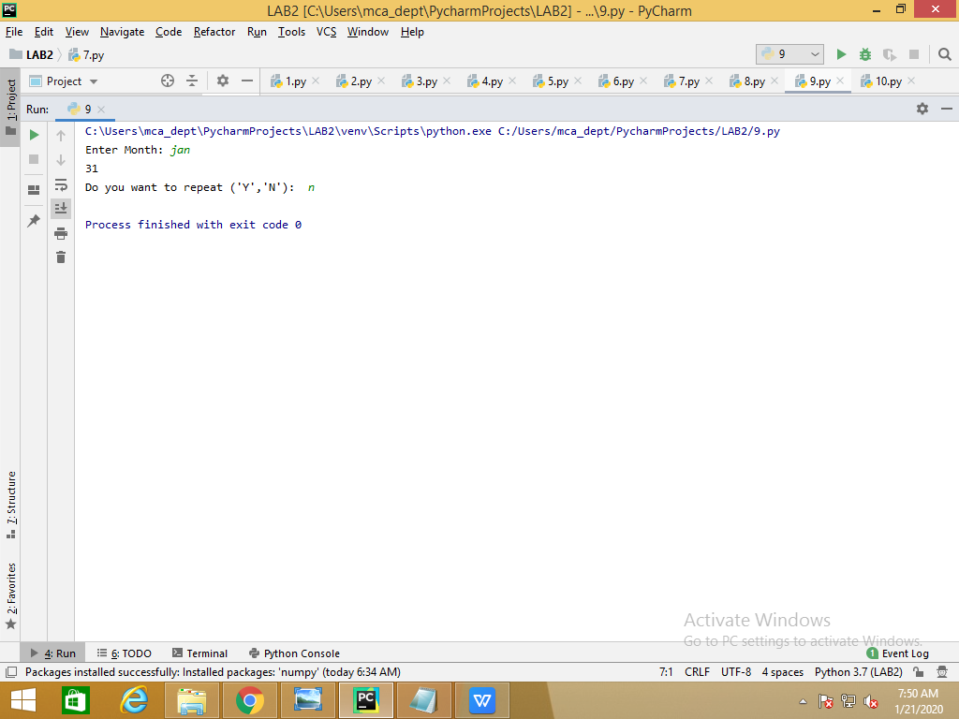

**8. 8.To check the validity of password input by users**

**Validation:**

**At least 1 letter between [a-z] and 1 letter between [A-Z].**

**At least 1 number between [0-9].**

**At least 1 character from [$#@].**

**Minimum length 6 characters.**

**Maximum length 16 characters.**

**Program:**

# WAP to validate a password

repeat = True

while repeat:

password = input("Enter a password: ")

special = ['~', '!', '@', '#', '$', '%', '^', '&', '*', '(', ')', '\'', '\"', ':', ';', '<', '>', '/', '?', '{',

'}',

'[', ']']

lower, upper, symbol, digit = 0, 0, 0, 0

for a in password:

if a.islower():

lower += 1

if a.isupper():

upper += 1

for s in special:

if a == s:

symbol += 1

if a.isdigit():

digit += 1

if len(password) < 6:

print("Password length must be greater than 6.")

elif len(password) > 16:

print("Password length must be lower than 16")

elif lower == 0:

print("Lower Case character missing.")

elif upper == 0:

print("Upper Case character missing.")

elif symbol == 0:

print("Special character missing.")

elif digit == 0:

print("Digit missing.")

else:

print("You entered a unique and valid password.")

repeat = input("\nCheck another password ('Y','N'): ")

if repeat in ['y', 'Y', 'yes', 'Yes', 'YES']:

continue

else:

repeat = False

**Output:**

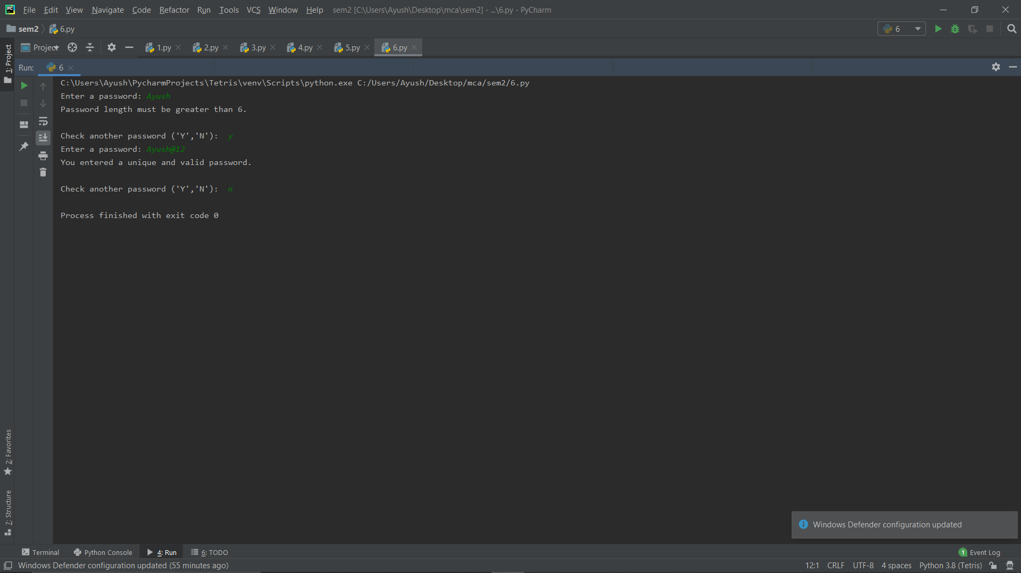

**9. WAP which iterates the integer from 1to 50.For multiples of three print “PYTHON” instead of number and for the multiples of five print “PROGRAMMING”. For numbers which are multiples of three and five print “PYTHON PROGRAMMING”**

**Program:**

for i in range(1,51):

if i%3 is 0 and i%5 is 0:

print("PYTHON PROGRAMMING")

elif i%3 is 0:

print("PYTHON")

elif i%5 is 0:

print(“PROGRAMMING")

**Output:**

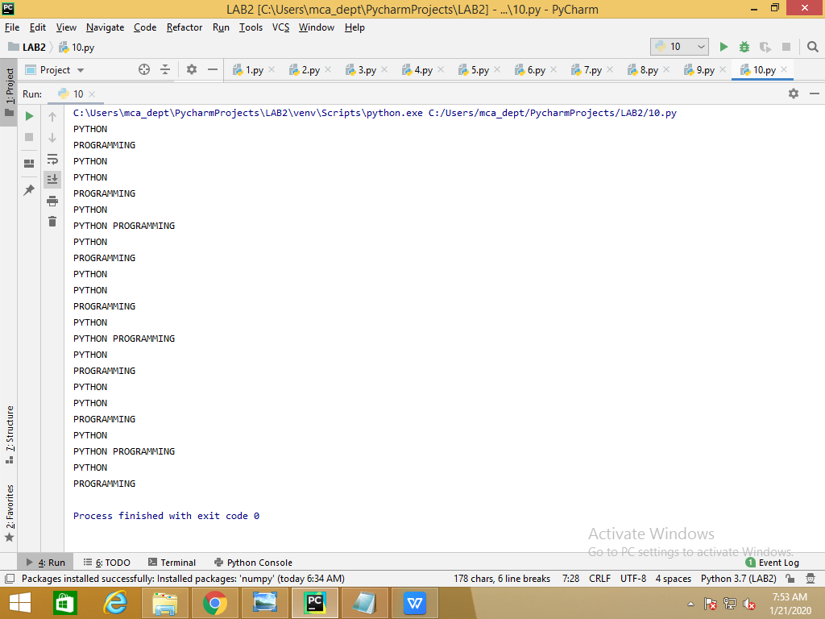

**10. Guessing a number**

**Program:**

import random

rand = random.randrange(1,100)

num = int(input("Enter a number: "))

while num!=rand:

if num > rand:

print("Your number is too big.")

else:

print("Your number is too small.")

num = int(input("Try Again: "))

print("Voila, same pinch.")

**Output:**

